|  |  |  |  |  |
| --- | --- | --- | --- | --- |
|  |  | | |  |
|  |  | | |  |
|  | Wechat | | |  |
|  | (MyFeatureId) | | |  |
|  |  | | |  |
|  |  | | |  |
| Document Type | **Feature Document (FD)** | | |  |
| Template Version | **6.0b** | | |  |
| Document ID | **document1** | | |  |
| Document Location |  | | |  |
| Document Owner | **Xu Zhang(xzhan304)** | | |  |
| Document Revision | **A** | | |  |
| Document Status | **Draft** | | |  |
| Date Issued | **2022-05-12** | | |  |
| Date Revised | **yyyy-mm-dd** | | |  |
| Document Classification | GIS1 Item Number: | **27.60/35** | |  |
| GIS2 Classification: | **Confidential** | |
|  | | | | |
|  | | | | |
| Document Approval | | | | |
| Person | Role | | Email Confirmation | Date |
|  |  | |  |  |
|  |  | |  |  |

Printed Copies Are Uncontrolled

# Disclaimer

**This document contains Ford Motor Company Confidential information. Disclosure of the information contained in any portion of this document is not permitted without the expressed, written consent of a duly authorized representative of Ford Motor Company, Dearborn, Michigan, U.S.A.**

**Copyright, Ó 2016 Ford Motor Company**

This document contains information developed and accumulated by and for FORD MOTOR COMPANY. As such, it is a proprietary document, which, if disseminated to unauthorized persons, would provide others with restricted information, data, or procedures not otherwise available, exposing the FORD MOTOR COMPANY to potential harm.

Employees and suppliers having custody of this specification or authorized to use it must be cognizant of its proprietary nature and ensure that the information herein is not made available to unauthorized persons.

FORD MOTOR COMPANY reserves the right to protect this work as an unpublished copyrighted work in the event of an inadvertent or deliberate unauthorized publication. FORD MOTOR COMPANY also reserves its rights under copyright laws to protect this work as a published work.

This document or portions thereof shall not be distributed outside FORD MOTOR COMPANY without prior written consent. Refer all questions concerning disclosure to the author(s) or to any duly authorized representative of Ford Motor Company.

# Contents

Disclaimer 2

Contents 3

1 Introduction 5

1.1 Document Purpose 5

1.2 Document Scope 5

1.3 Document Audience 5

1.3.1 Stakeholder List 5

1.4 Document Organization 5

1.4.1 Document Context 5

1.4.2 Document Structure 6

1.5 Document Conventions 6

1.5.1 Requirements Templates 6

1.6 References 7

1.6.1 Ford Documents 7

1.6.2 External Documents and Publications 7

1.7 Glossary 7

1.7.1 Definitions 7

1.7.2 Abbreviations 7

1.7.3 Parameters / Values 8

2 Feature Overview 9

2.1 Purpose and Description of Feature 9

2.2 Feature Variants 10

2.2.1 Regions & Markets 11

2.3 Input Requirements 11

2.3.1 Legal Requirements 11

2.3.2 Trustmark Requirements 11

2.3.3 Industry Standards 11

2.4 Lessons Learned 11

2.5 Assumptions 11

3 Feature Context 12

3.1 Feature Context Diagram 12

3.2 List of Influences 12

4 Feature Modeling 13

4.1 Operation Modes and States 13

4.2 Use Cases 13

4.2.1 Use Case Diagram 13

4.2.2 Actors 14

4.2.3 Use Case Descriptions 15

4.3 Driving and Operation Scenarios 15

4.4 Decision Tables 15

5 Feature Requirements 16

5.1 Functional Requirements 16

5.1.1 Error Handling 16

5.2 Non-Functional Requirements 16

5.2.1 Safety 16

5.2.2 Security 16

5.2.3 Reliability 16

5.3 HMI Requirements 16

5.4 Other Requirements 16

5.4.1 Design Requirements 16

5.4.2 Manufacturing Requirements 21

5.4.3 Service Requirements 21

5.4.4 After Sales Requirements 21

5.4.5 Process requirements 21

6 Functional Safety 22

6.1 System Behaviors for HARA 22

6.2 Safety Assumptions 22

6.3 Safety Goals 22

6.4 Functional Safety Requirements 23

6.4.1 <Goal 1 Name> 23

6.4.2 <Goal 2 Name> 23

6.4.3 Derivation of Requirements on Assumptions 23

6.5 (Decomposed) Functional Safety Requirements 23

7 Architecture 25

7.1 Functional Architecture 25

7.1.1 List of Functions 25

7.2 Logical Architecture 26

7.2.1 Logical Elements 27

7.2.2 Logical Interfaces 27

8 Open Concerns 29

9 Revision History 30

10 Appendix 31

**List of Figures**

Figure 1: Sample Context Diagram 11

Figure 2: Feature Operation Modes and States 13

Figure 3: Use Case Diagram 14

Figure 4: Functional Boundary Diagram 21

Figure 5: Logical Boundary Diagram 22

**List of Tables**

Table 1: Features described in this FD 5

Table 4: Ford internal Documents 7

Table 5: External documents and publications 7

Table 6: Definitions used in this document 7

Table 7: Abbreviations 7

Table 8: Parameters / Values used in this document 8

Table 2: Feature Variants 9

Table 3: Regions & Markets 9

Table 9: List of Influences 12

Table 10: Operation Modes and States 13

Table 11: Transitions between Operational Modes and States 14

Table 12: List of Actors 15

Table 13: Sample Decision Table 15

Table 14: System Behaviors for HARA 18

Table 15: Functional Safety Assumptions 18

Table 16: Functional Safety Goals 19

Table 17: Requirements Decomposition Table 20

Table 18: List of Functions 22

Table 19: Logical Elements 23

Table 20: Logical Interfaces 23

Table 21: Open Concerns 24

# Introduction

## Document Purpose

A Feature Document (FD) document specifies **what** the feature shall do and how it shall behave from customer perspective. It should also provide reasoning and background **why** we have the feature in the vehicle.

The FD also serves as an Item Definition as defined by ISO26262 for those features, which follow the Ford Functional Safety process.

To get more information about the concept of feature, function and component level abstraction refer to the [Ford RE Wiki](http://wiki.ford.com/display/RequirementsEngineering/Requirements+Engineering+for+SW+Enabled+Features). For details on the Ford Functional Safety (ISO26262) process refer to the [Ford Functional Safety Sharepoint](https://pd3.spt.ford.com/sites/GlobalFunctionalSafety/Pages/default.aspx).

## Document Scope

This Feature Document (FD) specifies the following features:

|  |  |  |  |
| --- | --- | --- | --- |
| **Feature ID** | **Feature Name** | **Owner** | **Reference** |
| <Add VSEM Global Feature Dictionary ID> | Wechat | Xu Zhang<xzhan304> | <Add VSEM Link> |
|  |  |  |  |

Table 1: Features described in this FD

## Document Audience

The FD is written by the feature owner of <Xu Zhang>. All Stakeholders, i.e., all people who have a valid interest in the feature should read and, if possible, review the FD. It needs to be guaranteed, that all stakeholders have access to the currently valid version of the FD.

**#Hint:** The FD template has the IP Classification “Proprietary” by default. IP Classification “Confidential” might be required in some cases, e.g. by Ford Functional Safety.

**#Macro:** [Add Ins -> Edit Document Properties macro](http://wiki.ford.com/display/RequirementsEngineering/How+to+use+the+Specification+Templates#HowtousetheSpecificationTemplates-EditDocProperties) (select “Proprietary” for “Document Classification”)

### Stakeholder List

For the latest list of stakeholder of the feature and their influence refer to <Put VSEM Link here>.

|  |  |  |  |
| --- | --- | --- | --- |
| **Name** | **CDSID** | **Role** | **Stakeholder Group** |
| Xu Zhang | xzhan304 | Tech Lead |  |
| Yu Wang | YWANG536 | Product Owner |  |
|  |  |  |  |
|  |  |  |  |
|  |  |  |  |
|  |  |  |  |

**#Hint:** Refer to [Ford RE Wiki – Stakeholder List](http://wiki.ford.com/display/RequirementsEngineering/Stakeholder+Analysis) on how to create a stakeholder list. The stakeholder list should be stored in VSEM in the pseudo folder “General Data Artifacts” of the corresponding feature.

## Document Organization

### Document Context

Refer to the [Specification Structure page](http://wiki.ford.com/display/RequirementsEngineering/Specification+templates) in the [Ford RE Wiki](http://wiki.ford.com/display/RequirementsEngineering/Requirements+Engineering+for+SW+Enabled+Features) to understand how the FD relates to other Ford Requirements Documents and Specifications.

### Document Structure

The structure of this document is explained below:

**Section 1** – Introduction how to use this document including responsibilities and requisite documents. Explains the terminology. Gives a clarification of the definitions, concepts and abbreviations used in the document.

**Section 2** – Feature Description. States briefly the background and the purpose of the feature, feature variants and corresponding regions and markets. Also includes input requirements, assumptions and constraints.

**Section 3** – Feature Context describes all external entities, which have an influence on the feature.

**Section 4** – Feature Modeling. Contains Use Case, Driving Scenarios, State Charts to describe the functional behavior of the feature.

**Section 5** – Safety. Lists System Behaviors and Safety Goals of the feature.

**Section 6** – Feature Requirements. Lists functional and non-functional requirements of the feature.

**Section 7** – Architecture. Shows the coarse architecture, which the feature requirements are deployed to. Describes the elements and the boundary of the feature as well as the decomposition and distribution of associated functions.

**Section 8** – List of Open Conerns

**Section 9** – Document Change History including a list of new or modified requirements. The requirements in this document are tagged, and this section contains different types of tables listing all, new, or changed requirements by their title and page no.

**Section 10** – Appendix

**#Hint:** All sections are mandatory, unless explicitly marked by the tag “#Classification” as “optional” or as applicable e.g. to certain domains like “Functional Safety”.

## Document Conventions

### Requirements Templates

Each requirement, use case or scenario in this specification shall follow the corresponding template given in the document template *Specification_Macros.dotm* at [RE Wiki - Specification Templates](http://wiki.ford.com/display/RequirementsEngineering/Specification+templates?src=contextnavpagetreemode).

**#Hint:** The Specification_Macros.dotm template also provides macros to insert the requirement templates. Refer to “[How to use the Specification Templates](http://wiki.ford.com/display/RequirementsEngineering/How+to+use+the+Specification+Templates?src=contextnavpagetreemode)” on how to enable the macros and the requirements templates in this specification.

The requirements macro and requirements templates also enable the import of the specification to VSEM (refer to ["How to import specifications into VSEM as separate requirements"](http://wiki.ford.com/pages/viewpage.action?pageId=104991616&src=contextnavpagetreemode)).

#### Identification of requirements

The unique requirement ID given in the headline of any requirement follows the requirement throughout the development process. The requirement ID format follows a well-defined syntax.

All identifiers in a FD shall be composed of 4 parts:

* A leading prefix, which indicates the type of requirement (R=Requirement, UC=Use Case, SC=Scenario, …)
* A prefix, which indicates the abstraction level (F=Feature, FNC=Function, CMP = component).
* Followed by a name, indicating the scope, which the requirement belongs to (e.g. feature or function name )
* Ending with the actual requirement number

*Example:*

*R_F_AutoLamps_00004* This is the fourth requirement on feature level for the feature Autolamps.

#### Requirements Attributes

The templates provided by *Specification_Macros.dotm* define a list of attributes for each requirement. This helps to classify the requirement. The attributes are explained at [RE Wiki - Requirements Attributes](http://wiki.ford.com/display/RequirementsEngineering/Requirements+Attributes?src=contextnavpagetreemode).

## References

### Ford Documents

List here all Ford internal documents, which are directly related to the feature.

| **Reference** | **Title** | **Doc. ID** | **Document Location** | **Revision** |
| --- | --- | --- | --- | --- |
| [aaa] |  |  |  |  |
|  |  |  |  |  |

Table 2: Ford internal Documents

### External Documents and Publications

The list of external documents could include books, reports and online sources.

**#Hint:** You may refer to [IEEE Citation Reference](http://www.ieee.org/documents/ieeecitationref.pdf) on how to format a reference.

| **Reference** | **Document / Publication** | **Document Location** |
| --- | --- | --- |
| [bbb] |  |  |
|  |  |  |

Table 3: External documents and publications

## Glossary

**#Hint**: Terms, concepts and abbreviations used in the document shall be defined and illustrated here. Note that changes to terms and/or concepts described in this section tend to cause major updates to this document.

The tables below have feature specific definitions and abbreviations. For additional, non-feature specific terms please refer to the [RE Glossary](http://wiki.ford.com/display/RequirementsEngineering/Glossary?src=contextnavpagetreemode)

### Definitions

| **Definition** | **Description** |
| --- | --- |
|  |  |
|  |  |
|  |  |
|  |  |
|  |  |
|  |  |
|  |  |

Table 4: Definitions used in this document

### Abbreviations

| **Abbr.** | **Stands for** | **Description** |
| --- | --- | --- |
|  |  |  |
|  |  |  |
|  |  |  |
|  |  |  |
|  |  |  |

Table 5: Abbreviations

### Parameters / Values

| **Name** | **Description** | **Range / Resolution** |
| --- | --- | --- |
|  |  |  |
|  |  |  |
|  |  |  |

Table 6: Parameters / Values used in this document

# Feature Overview

## Purpose and Description of Feature

**#Hint:** Some descriptive text to explain the purpose and functionality of the feature.

将微信（Wechat）移植到车辆上。微信功能属于腾讯随行整体功能的一个子项，随行功能包含小程序卡与微信卡两部分，此文档将着重描述微信功能的需求；

微信具备未读消息提醒、快速发起发微信流程、快速发起拨打微信通话流程、实时位置共享（建设中）、消息设置，功能样式如图所示。

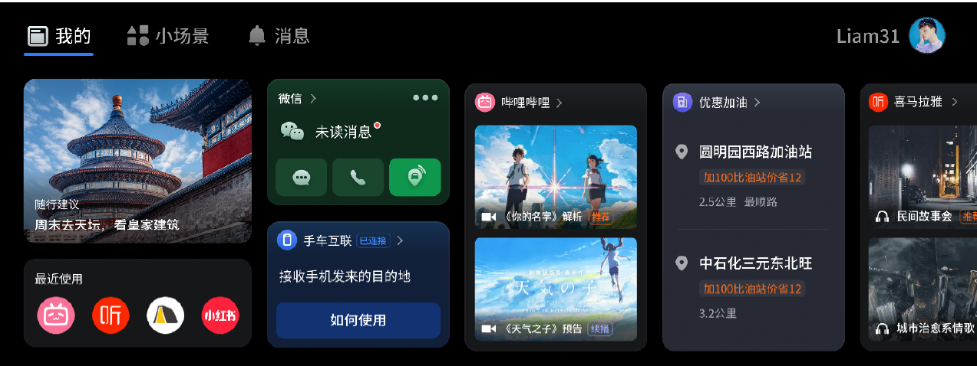

**微信有新消息：**

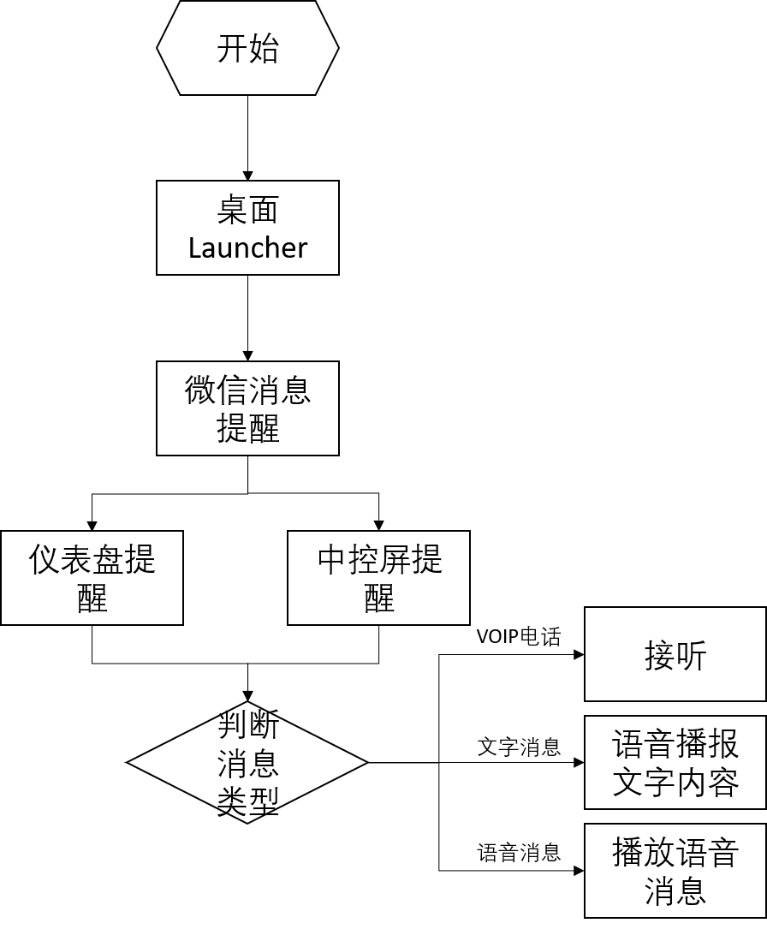

**主动使用微信**

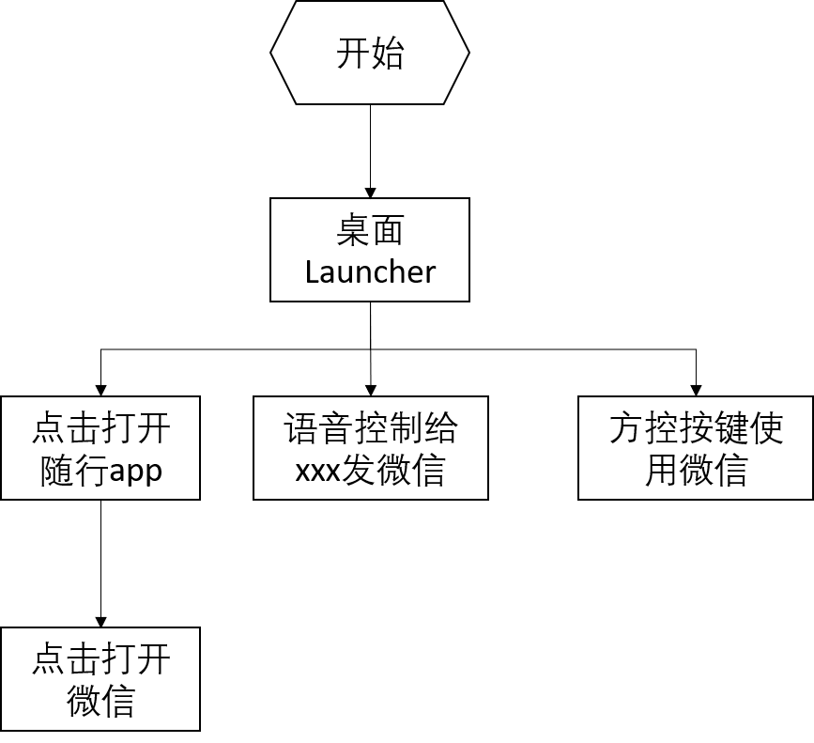

## Feature Variants

**#Hint:** Definitions for different variants of the feature (if applicable). Give each variant a descriptive name by which it can be referenced further on in the document. If no variant exists, state “No Feature Variants”.

The Variant Description should give a short informative text which describes the variants of the feature.

|  |  |  |
| --- | --- | --- |
| Variant Name | Variant Description | Remarks |
|  | No Feature Variants |  |
|  |  |  |
|  |  |  |

Table 7: Feature Variants

### Regions & Markets

**#Hint:** Description of purpose and functionality of the feature. If there is no variant, give feature name in first column.

|  |  |  |  |  |  |  |
| --- | --- | --- | --- | --- | --- | --- |
| **Market /**  **Region**  Variant Name | **North America** | **South America** | **Europe** | **Middle East / Africa** | **Asia / Pacific** | **China** |
| **Smart Rcommendation** |  |  |  |  |  | *Y* |

Table 8: Regions & Markets

## Input Requirements

**#Hint:** List all input requirements, which are relevant for the feature. Typically, attribute requirements, legal requirements as well as national and international standards have to be considered.

### Legal Requirements

TBD

1.用户隐私协议；

### Trustmark Requirements

### Industry Standards

## Lessons Learned

**#Hint:** Additional information and lessons learned from previous development or related features. A typical source for Lessons Learned is the FMA Quality History.

**#Functional Safety:** In context of Functional Safety Lessons Learned and similar information will be used to check the completeness of the Functional Safety Goals and assumptions in the Hazard Analysis and Risk Assessment (HARA).

**#Link:** [Ford Functional Safety Sharepoint](https://pd3.spt.ford.com/sites/GlobalFunctionalSafety/Pages/default.aspx)

1. 总线信号丢失；
2. 数据传输过程中突然失去供电；
3. 数据传输过程中网络信号不稳定；

## Assumptions

**#Classification**: Optional

**#Hint:** A list of known assumptions concerning the effects of the feature’s behavior on other features or elements (i.e., dependencies) as well as assumptions on the behavior expected by the feature (e.g. known limitations). During the course of the feature development most of those assumptions are typically either converted into actual requirements or discarded at some point – such that this chapter remains mostly empty. For assumptions, which are relevant for the Functional Safety process refer to chapter 6.2 “Safety Assumptions”

# Feature Context

## Feature Context Diagram

**#Hint:** High level diagram of feature interactions with the environment, people or other feature or other external entities.

**#Link:** [RE Wiki - Context Diagram](http://wiki.ford.com/pages/viewpage.action?pageId=107676234&src=contextnavpagetreemode)

**

Figure 1: Sample Context Diagram

## List of Influences

|  |  |  |
| --- | --- | --- |
| **ID** | **External Entity** | **Influence Description** |
| I1 | Power Supply | 功能需要在有供电的情况下实现 |
| I2 | Vehicle Status | 功能实现需要判断车辆状态，如蓝牙状态、音频通道状态等 |
| I3 | Mini App | 微信卡片展示依赖于与小程序卡片的整体布局 |
| l4 | MAP | 手机微信分享到车端的位置信息可以进行导航 |
|  |  |  |

Table 9: List of Influences

# Feature Modeling

## Operation Modes and States

**#Classification:** Optional (Mandatory for Functional Safety)

**#Link:** [RE Wiki – State Charts](http://wiki.ford.com/display/RequirementsEngineering/State+Charts?src=contextnavpagetreemode)

**#Hint:** State Charts are a popular means to express feature behavior in terms of states and modes. An advantage of this state machine like approach is that consistency can be easily verified.

Figure 2: Feature Operation Modes and States

|  |  |  |
| --- | --- | --- |
| **State** | **Description** | **Requirements Reference** (optional) |
| S1 | Standby | 微信在后台时 |
| S2 | Listen/play | 微信在前台时播放语音消息或进行声音录入 |
| S3 | Call | 进行微信语音电话时的状态 |
|  |  |  |
|  |  |  |
|  |  |  |

Table 10: Operation Modes and States

|  |  |  |
| --- | --- | --- |
| **Transition ID** | **Description** | **Requirements Reference**  (optional) |
| T1 | 选择唤起微信播放语音消息或播放语音消息 |  |
| T2 | 播放或倾听场景结束 |  |
| T3 | 播放或倾听场景时接通语音电话 |  |
| T4 | 微信处于后台状态时，接通语音电话； |  |
| T5 | 退出语音电话，微信恢复后台状态 |  |

Table 11: Transitions between Operational Modes and States

## Use Cases

**#Classification:** Optional

**#Link:** [RE Wiki – Use Cases](http://wiki.ford.com/display/RequirementsEngineering/Use+Cases+Overview?src=contextnavpagetreemodehttp://wiki.ford.com/display/RequirementsEngineering/Use+Cases?src=contextnavpagetreemode)

### Use Case Diagram

**

Figure 3: Use Case Diagram

### Actors

| Actor | Description |
| --- | --- |
|  |  |
|  |  |
|  |  |

Table 12: List of Actors

### Use Case Descriptions

**#Classification:** Optional

**#Macro:** [Add Ins -> Add Requirement macro](http://wiki.ford.com/display/RequirementsEngineering/How+to+use+the+Specification+Templates#HowtousetheSpecificationTemplates-AddNewRequirement) (select “Use Case” as type)

注：Failure behavior的序号对应Expected Behavior中的序号，具体针对对应序号的行为没有按照期望实现时所采取的措施。

Use Case时序后续补充

## Driving and Operation Scenarios

**#Classification:** Optional (Mandatory for Functional Safety)

**#Macro:** [Add Ins -> Add Requirement macro](http://wiki.ford.com/display/RequirementsEngineering/How+to+use+the+Specification+Templates#HowtousetheSpecificationTemplates-AddNewRequirement) (select “Scenario” as type)

**#Functional Safety:** Driving and operating scenarios which impact the functionality of the feature can be used to check, if the situation analysis in the HARA is complete

**#Link:** [RE Wiki – Driving Scenarios](http://wiki.ford.com/display/RequirementsEngineering/Driving+Scenarios?src=contextnavpagetreemode)

## Decision Tables

**#Classification:** Optional

**#Link:** [RE Wiki – Decision Tables](http://wiki.ford.com/display/RequirementsEngineering/Decision+Table).

**#Hint:** Use decision table, if behavior is not state based (in that case prefer state chart from ch. 4.1) and based purely on current inputs.

|  |  |  |  |  |
| --- | --- | --- | --- | --- |
| **Input Signal 1** | **Input Signal 2** | **Input Signal 3** | **Input Signal 4** | **Output Signal** |
| Value I1 | Value I2 |  |  | Value O1 |
|  |  |  |  |  |

Table 13: Sample Decision Table

# Feature Requirements

**#Macro:** [Add Ins -> Add Requirement macro](http://wiki.ford.com/display/RequirementsEngineering/How+to+use+the+Specification+Templates#HowtousetheSpecificationTemplates-AddNewRequirement) (select “Requirement” as type)

**#Functional Safety:** In general, safety requirements are not listed here. However, it is possible that later in the development process, a non-safety requirement becomes a safety requirement. In such a case it may remain on this list.

**#Link:** [RE Wiki – How to write good requirements](http://wiki.ford.com/display/RequirementsEngineering/How+to+write+better+requirements?src=contextnavpagetreemode).

## Functional Requirements

### Error Handling

## Non-Functional Requirements

***#Hint:*** *Non-functional requirements specify some performance criteria in addition to the functional behavior given defined by the functional requirements. Timing (if not already included in the functional requirements), security details (e.g. how secure does an algorithm have to be) reliability (e.g. mean time between failure) or maintainability could be specified in this section.*

### Safety

**#Hint:** Only those safety requirements, which are not related to Functional Safety (ISO26262) should go here. For Functional Safety refer to chapter 6 “Functional Safety”.

### Security

TBD

### Reliability

## HMI Requirements

**#Hint:** Requirements in this section could specify details of e.g. the icons, the GUI or the sounds.

## Other Requirements

### Design Requirements

***#Hint:*** *Requirements of a Logical Function should be typically agnostic of their SW/HW implementation*. If for specific reasons the function owner needs to define explicitly design constraints on the solution, it can be done in this chapter.

#### 整体功能描述

1. 车载微信需要与手机微信进行登录状态同步；
2. 微信消息需要与手机消息进行状态同步；
3. 所有微信消息在车端均以语音消息体现；
4. 支持车端微信音频通话；
5. 支持车载语音控制微信行为；
6. 支持方向盘控制按键控制微信行为；
7. 支持APP store升级；

|  |  |  |  |  |  |
| --- | --- | --- | --- | --- | --- |
| 核心模块 | Lv1分类 | Lv2分类 | 微信**X.X** | 优先级 | 端 |
| 交互 | 安全便捷交互 | 方控控制 | 1. 支持方向盘按键控制：上、下、左、右、确定、接听、挂断 2. 支持中控按键控制，与方向盘按键一致 | 1. 高 | 1. IVI |
| 语音快捷控制 | 详见8.2 语音领域技能 的微信功能领域 | 高 | IVI |
| 微信按键引导 | 微信首次登录后展示方控使用教程 | 高 | IVI |
| 账号 | 微信账号登录 | 初次上车扫码登录 | 用手机微信扫描车机上显示的二维码，微信账号信息加载在车机屏幕上，并要求在手机上确认登录。手机上点击确认后完成车机端登录。（该过程类似微信PC端初次登录流  程） | 高 | IVI |
| 再次上车登录 | 车机上显示微信账号，点击登录后要求在手机上确认登录。手机上点击确认后完成车机  端登录。（该过程类似微信PC端初次登录流程） | 高 | IVI |
| 微信账号登出 | 自动登出 | 熄火后自动登出账号 | 高 | IVI |
| 手动登出 | 用户操作以登出账号 | 高 | IVI |
| 信息 | 个人信息 | 状态、联系人、设置等车机端会与手机端自动同步 | 高 | IVI |
| 消息 | 查看未读消息 | 查看未读消息 | 可主动发起未读消息的查看。 | 高 | IVI |
| 收微信消息  （部分支持仪表投射） | 收到文字消息 | 提示有新消息音效，TTS播报文字消息内容 | 高 | IVI |
| 收到语音消息 | 提示有新消息音效，播报语音消息内容； | 高 | IVI |
| 收到POI消息 | 微信好友发来POI位置，有新消息音效，新消息，车机端收到位置信息查看，可在地图  中发起导航 | 高 | IVI |
| 收到表情/图片/符号/链接等消  息 | 提示有新消息音效，播报发来的消息类型，但无法在车机端查看。某些情况下，可能会  出现无法识别链接类型 | 高 | IVI |
| 收到不支持的消息 | 提示有新消息音效，播报发来不支持的消息，无法在车机端查看 | 高 | IVI |
| 发微信消息 | 搜索联系人 | 说出名字搜索联系人，匹配微信联系人 | 高 | IVI |
| 最近联系人 | 没有主动指定联系人的情况下，展示最近联系的联系人或群列表 | 高 | IVI |
| 发消息 | 语音发消息给某一联系人，发送的消息为语音消息 | 高 | IVI |
| 聊天记录 | 消息 | 车机保留用户好友的头像缓存及系统日志，不对信息内容进行保存 | 高 | IVI |
| 免打扰 | 屏蔽消息 | 用户发出语音指令“屏蔽消息”后可在当次登录时屏蔽该联系人的消息。 | 高 | IVI |
| 忽略 | 用户可通过方按键/语音忽略此次消息。 | 高 | IVI |
| VOIP通话 | 发起语音通话 | 搜索联系人 | 说出名字搜索联系人，匹配微信联系人 | 高 | IVI |
| 最近联系人 | 没有主动指定联系人的情况下，展示最近联系的联系人或群列表 | 高 | IVI |
| 发起语音通话 | 语音选择联系人并发起通话。群的语音通话不支持。 | 高 | IVI |
| 接听语音通话 | 接听语音通话 | 车机端显示语音通话来电，视频通话自动转为语音通话  ，可以选择接听或挂断。群的语音通话暂不支持。 | 高 | IVI |
| 通话中 | 最小化 | 可最小化通话窗口 | 高 | IVI |
| 挂断 | 可通过方控或触控挂断VOIP | 高 | IVI |
|  | 通知提示设置 | 消息音频提示方式（新） | 可在完整播报，仅提示音，静音，三种模式中选择 | 高 | IVI |
| 仪表消息展示（新） | 开关，打开后消息提示将在仪表中展示。用户响应后回到中控完成后续流程 | 高 | IVI |
| 其他设置 | 开机自动启动（新） | 开关，打开后微信将在车辆启动后自己打开（但不是自动登录）。 | 高 | IVI |
| 关于 | 提交反馈 | 引导用户扫描微信车载版公众号二维码，在公众号内提供反馈渠道 | 高 | IVI |
| 上传日志 | 用户可选择按自然日为维度的日志上传，帮助微信团队定位问题 | 高 | IVI |
| 帮助 |  | 引导用户扫描微信车载版公众号二维码，在公众号内提供使用帮助 | 高 | IVI |
| 升级 | 微信升级 |  | 微信日常版本更新跟随车机系统或应用商店升级  微信在紧急情况下可自升级，仅用于应对突发情况 | 高 | IVI |

参考文件：

   

#### 硬件依赖

1.系统资源需求；

详见《腾讯随行TAI 3.0系统依赖》章节2.1

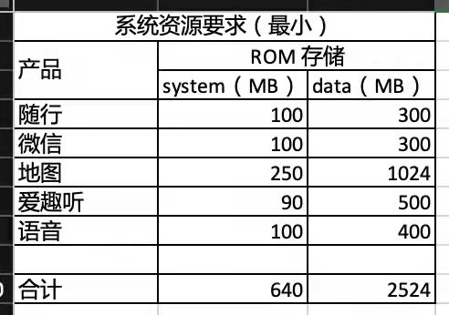

2.惯导要求

详见《腾讯随行TAI 3.0系统依赖》章节2.2.2

3.方向盘按键

支持区分长按短按事件；

#### 系统交互和接口依赖

1.方向盘按键：

方控按键也是必不可少的一个交互方式，腾讯随行支持集成方控按键，通过方控按键方式来

操控。比如，给一个单独的方控按键给车载微信使用， 支持单击， 长按事件。根据《腾讯车联OpenSDK-PAL平台适配接口列表》进行接口提供；

复用语音唤醒按键，在微信未被调起时，单击为唤醒语音，双击为唤醒微信。在微信被调起的状态下，则此按键都为微信所用，直到微信回到后台再交回给语音唤醒能力

|  |  |  |
| --- | --- | --- |
| 状态/页面 | 语音键短按 | 语音键长按 |
| 发送语音页面 | 发送 | 取消 |
| 普通消息通知页面 | 播报 | 忽略 |
| 普通消息播报页 | 回复 | 取消 |
| 特殊消息通知页面 |  | 忽略 |
| POI消息通知页面 | 查看 | 忽略 |
| 群消息通知页面 | 播报 | 忽略 |
| 特殊群消息通知页面 |  | 忽略 |
| 群消息播报页 | 回复 | 取消 |
| 播报结束页面 | 回复 | 取消 |
| 收到VOIP | 接听 | 挂断 |
| 拨打VOIP |  | 挂断 |

2.音源管理和仲裁

语音作为车机端app 的一个主要交互，音源冲突在所难免， 音源仲裁对随行体验很重要。

腾讯随行默认采用Android系统音源仲裁方案，保障仲裁策略。

3.GUI仲裁

腾讯随行通过window.addView()进行消息卡片的展示， 和系统app 之间的仲裁依赖系统配合。需要进行GUI仲裁的场景如下：

蓝牙电话场景：

收到蓝牙电话后微信消息， voip关闭， 所以需要系统通过广播的方式通知微信蓝牙电话状态， 广播的action和数据格式系统定义， app层参照系统定义接收解析广播并做并做相应的处理。

倒车/ebcall/AVM场景：

同蓝牙电话场景， 随行消息关闭， 具体状态通过广播通知app，广播action， 数据格式系统定义。

详见《腾讯随行TAI 3.0系统依赖》章节3.3

4.录音

腾讯随行使用android系统标准的录音接口进行录音并识别，随行拿到录音数据后不会做降噪， 回声消除处理， 依赖系统进行处理， 同时需要系统提供一批录音数据进行训练

使用方法详见《腾讯随行TAI 3.0系统依赖》章节3.4；

5.Voip电话仲裁

前提：

(1) 手机微信账号登录车机

(2) 手机和车机通过蓝牙连接

现象及问题：

某些安卓手机存在一个bug, 收到voip 时手机版微信为支持蓝牙耳机等蓝牙外设接听voip，会主动发送蓝牙通话协议， 车机收到后会拉起蓝牙电话界面，由于蓝牙通话优先级较高，会把车机voip电话打断掉， 导致voip无法在车机端使用。

为解决上述问题，系统侧需要通过音频仲裁实现以下策略：

(1) 未接听状态下的蓝牙电话和未接听状态下的VOIP可以共存。

(2) 任意一方接听后可以打断处于接听状态的另一方。

(3) 接听VOIP时，蓝牙电话如果处于等待接听中，则不挂断蓝牙电话。

(4) 手机端接听蓝牙电话时，VOIP如果处于等待接听中，会被手机直接挂断。

(5) 车机端接听蓝牙电话时，VOIP如果处于等待接听中，不会挂断VOIP。

接口使用方法详见《腾讯随行TAI 3.0系统依赖》章节3.5；

6. PAL集成

按照《腾讯车联OpenSDK-PAL平台适配接口列表》接口要求提供；

7.微信调用SDK集成

按照《TAI - WeChat Auto SDK User Guide》集成；

8.语音控制

语料以《TAI 融合语音功能清单 0506》内容为准；

9.埋点

满足福特埋点要求；

### Manufacturing Requirements

### Service Requirements

**#Hint:** Requirements in this section could specify, e.g. what needs to be considered, if individual ECUs are replaced or new SW is flashed to ECUs (parameter set in non-volatile memory might get inconsistent and needs also to be updated).

### After Sales Requirements

**#Hint:** Requirements in this section could specify, e.g. input for the Owner’s Manual could be gathered.

### Process requirements

**#Hint**: Requirements in this section are relevant for the development process of the feature, e.g. ISO26262 compliance.

# Functional Safety

**#Classification**: Functional Safety only

**#Hint:** This section is dedicated to the Ford Functional Safety (ISO26262) process. For details of this process refer **#Link:** [Ford Functional Safety Sharepoint](https://pd3.spt.ford.com/sites/GlobalFunctionalSafety/Pages/default.aspx)

**#Contact:** [*RE Wiki Roles & Responsibilites page – Role: Application Functional Safety Engineer*](http://wiki.ford.com/display/RequirementsEngineering/Default+Contacts+for+Stakeholder+Roles#ApplicationFunctionalSafetyEngineer)

## System Behaviors for HARA

**#Classification**: Functional Safety only

**#Hint:** List of selected system behaviors is an input to the Hazard Analysis and Risk Assessment (HARA). There needs to be a rationale why other system behaviors / functions are not considered.

|  |  |
| --- | --- |
| ID | Name |
| **F_ATC_U0002** | Tilt the vehicle body |

Table 14: System Behaviors for HARA

## Safety Assumptions

**#Hint:** Copy the assumptions from the document "FFSD 02 Hazard Analysis and Risk Assessment”, Tab. “2 - Assumptions” with “Ref/ID”, “Name”, “Category”, “Description”, “Purpose”. In this document, additionally a reference to the requirement ID is inserted.

**#Link:** [Functional Safety Sharepoint](https://pd3.spt.ford.com/sites/GlobalFunctionalSafety/Pages/default.aspx) – HARA

|  |  |  |
| --- | --- | --- |
| ID | Assumption | |
| **1** | **Name** |  |
| **Description** |  |
| **Purpose** |  |
| **Category** |  |
| **Related Requirements IDs** |  |
| **2** | **Name** |  |
| **Description** |  |
| **Purpose** |  |
| **Category** |  |
| **Related Requirements IDs** |  |

Table 15: Functional Safety Assumptions

## Safety Goals

**#Classification**: Functional Safety only

**#Hint:** The list of Functional Safety Goals is an output of the Hazard Analysis and Risk Assessment (HARA) and therefore not required during the initial creation of the Feature Document.

**#Link:** [Functional Safety Sharepoint](https://pd3.spt.ford.com/sites/GlobalFunctionalSafety/Pages/default.aspx) – HARA

|  |  |  |  |  |
| --- | --- | --- | --- | --- |
| ID | Goal | | | |
| **1** | **Goal Name** |  | | |
| **Description** |  | | |
| **Safety Goal Concept** | <fill in Safety Goal Concept incl. the Warning & Recovery Concept and also the Safe Statel> | | |
| **ASIL** |  | **FTTI** | <fill in Fault Tolerant Time Interval (if applicable)> |
| **Related FSR IDs** |  | | |
| **2** | **Goal Name** |  | | |
| **Description** |  | | |
| **Safety Goal Concept** | <fill in Safety Goal Concept incl. the Warning & Recovery Concept and also the Safe State> | | |
| **ASIL** |  | **FTTI** | <fill in Fault Tolerant Time Interval (if applicable)> |
| **Related FSR IDs** |  | | |

Table 16: Functional Safety Goals

## Functional Safety Requirements

**#Classification**: Functional Safety only

**#Hint:** The section lists the Functional Safety Requirements (FSRs) derived from a Safety Goal and Assumptions.

The following should be noted for the use of the attribute fields for FSRs

- The “Source Req” trace link field in each FSR should have a reference to

- a safety goal in ch. 6.3 “Safety Goals” or

- an assumption in ch. 6.2 “Safety Assumptions”

**#Link:** [Functional Safety Sharepoint](https://pd3.spt.ford.com/sites/GlobalFunctionalSafety/Pages/default.aspx) – Functional Safety Concept

[RE Wiki - Requirements Attributes](http://wiki.ford.com/display/RequirementsEngineering/Requirements+Attributes)

### <Goal 1 Name>

### <Goal 2 Name>

### Derivation of Requirements on Assumptions

**#Classification**: Functional Safety only

**#Hint:** Derive requirements from the Assumptions (refer to section “Safety Assumptions”

## (Decomposed) Functional Safety Requirements

***#Classification:*** *Functional Safety Only*

***#Hint:*** *For ASIL D features additional measures like a requirements decomposition might be required. Fill out the following table for each ASIL D decomposition applied in the feature. The decomposition rationale is the reason why the decomposition was performed, whereas the rationale for each requirement expresses the reason and thought behind that particular requirement and should include how the requirement is able to independently fulfill the needs of the parent requirement.*

***#Link:***[*Functional Safety Sharepoint*](https://pd3.spt.ford.com/sites/GlobalFunctionalSafety/Pages/default.aspx) *- Functional Safety Concept*

| Initial Safety Requirement | Functional Safety Requirement X | |
| --- | --- | --- |
| Decomposition Rationale |  | |
| Method for Decomposition | Choose a Method | |
| Functional Safety Requirement 1 after Decomposition | F-S-Req-ID |  |
| F-S-Req. Title |  |
| ASIL |  |
| Rationale |  |
| Allocated to |  |
| Functional Safety Requirement 2 after Decomposition | F-S-Req-ID |  |
| F-S-Req. Title |  |
| ASIL |  |
| Rationale |  |
| Allocated to |  |
| Functional Safety Requirement for Independence  *Note: should consider commonly used input, output and processing*  *Note: additional row should be added if additional* *requirements for Independence are necessary* | F-S-Req.-ID |  |
| F-S-Req. Title |  |
| ASIL |  |
| Rationale |  |

Table 17: Requirements Decomposition Table

# Architecture

## Functional Architecture

**#Classification:** Mandatory for Functional Safety – otherwise optional

**#Hint**: This section depicts the coarse Functional Architecture. This architectural step is needed to find the right functional partitioning for the function level. The function shown here are those, which are specified on function level. Either SysML activity diagrams or Data Flow Diagrams could be used to depict such a Functional Architecture. For bigger features, which are decomposed in a hierarchical manner down to atomic functions (and which do not follow the Functional Safety process), a function tree could be given here.

**#Links:**

* Functional Decomposition: [RE Wiki – Functional Decomposition](http://wiki.ford.com/display/RequirementsEngineering/Functional+Decomposition)
* SysML - Activity Diagrams or [RE Wiki - Data Flow Diagrams](http://wiki.ford.com/display/RequirementsEngineering/Data+Flow+Diagram?src=contextnavpagetreemodehttp://wiki.ford.com/display/RequirementsEngineering/Data+Flow+Diagram?src=contextnavpagetreemode)
* Data Flow Diagram: [RE Wiki – Data Flow Diagram](http://wiki.ford.com/display/RequirementsEngineering/Functional+Decomposition)



Figure 4: Functional Boundary Diagram

### List of Functions

**#Hint:** The functions shown in the Functional Architecture should be listed and described in the table below

| Function Name | Description | Comments |
| --- | --- | --- |
|  |  |  |
|  |  |  |
|  |  |  |
|  |  |  |
|  |  |  |
|  |  |  |
|  |  |  |
|  |  |  |

Table 18: List of Functions

## Logical Architecture

**#Classification:** Functional SafetyAnalysis only

**#Hint:** FS Analysis requires a description of the boundary of the feature and its elements. A simple block diagram or a SysML Internal Block Diagram could be used to depict the Logical Architecture

**#Link:** [Ford Functional Safety Sharepoint](https://comm.sp.ford.com/sites/GlobalFunctionalSafety/Pages/default.aspx)

**

Figure 5: Logical Boundary Diagram

### Logical Elements

**#Hint:** Lists the elements of the Logical Architecture and the functions from the Functional Architecture, which are allocated to those elements.

|  |  |  |  |
| --- | --- | --- | --- |
| **Element Name** | **Description** | **Allocated Functions** | **Comments** |
| e.g. Active Tilt Controller | … | e.g. Control Value |  |
|  |  |  |  |
|  |  |  |  |

Table 19: Logical Elements

### Logical Interfaces

**#Hint:** Describe the interactions of the feature with other features or elements.

|  |  |  |  |
| --- | --- | --- | --- |
| **Interface Name** | **Direction** | **Description** | **Value Range** |
| e.g. Vehicle tilt angle | e.g. Tilt angle sensor to ATC | … | e.g. -45deg to +45deg |
|  |  |  |  |
|  |  |  |  |

Table 20: Logical Interfaces

# Open Concerns

**#Hint:** The following list presents open concerns, which have to be discussed or clarified over the course of the on-going requirements engineering.

| ID | Concern Description | e-Tracker / Reference | Responsible | Status | Solution |
| --- | --- | --- | --- | --- | --- |
| 1 |  |  |  |  |  |
| 2 |  |  |  |  |  |
| 3 |  |  |  |  |  |
| 4 |  |  |  |  |  |
| 5 |  |  |  |  |  |
| 6 |  |  |  |  |  |
| 7 |  |  |  |  |  |
| 8 |  |  |  |  |  |
| 9 |  |  |  |  |  |

Table 21: Open Concerns

# Revision History

**#Hint:** A new version number is assigned to a document with a given revision each time it is checked in to Team Center (TCSE). After release of a revision, the document cannot be edited and no new versions can be created on that revision. When updating the document after that, a new revision has to be created and new versions on that revision will be created upon checking in.

| Rev.  (revision) | Date | Description | Responsible |
| --- | --- | --- | --- |
| *1.0* |  | *Initial version* | *Xzhan304* |

## Template Revisions

*#Important: Do not change this section*

|  |  |  |  |  |
| --- | --- | --- | --- | --- |
| Version | Rev. | Date | Description | Responsible |
| *0* | *6* | *2015-05-26* | * *Chapter “Feature Overview” and made a 2nd level heading.* * *Chapter “Feature Modeling” divided into 3 subchapter (“Scenarios”, “Use Cases”, “State Machines”) for different modeling methods* | *Jbaden1* |
| *0* | *7* | *2015-05-27* | * *Table of Content updated* * *Template Revision History chapter added* | *Jbaden1* |
| *0* | *8* | *2015-07-02* | * *Section “Unsettled Issues” added* | *Alevin7* |
| *0* | *9* | *2015-08-04* | * *Section “Feature Variants” added* * *Section “Feature Boundary Diagram” renamed to “Feature Context Diagram”* * *Document Properties adapted to match needs of VBA macros* | *Jbaden1, Awegman1* |
| *1* | *0* | *2015-09-11* | * *Section “Feature Variants” reworked* * *Feature Goals removed. Only “Safety Goals“ chapter remains.* * *Heading 2 formatting issues corrected.* * *Requirements / Use Cases Listing removed from traceability chapter.* * *Formatting of attribute table in Notation chapter corrected* * *Open Topics / Known Issues chapter moved to the end* | *Jbaden1* |
| *1* | *1* | *2015-11-16* | * *Table-Styles removed (for smooth VSEM import)* * *Some clean-up of sections “Purpose” and “Audience”* | *Awegman1, jbaden1* |
| *1* | *2* | *2016-02-26* | * *Minor corrections based on lessons learned from CC and PCL pilot (e.g. section market/regions) and discussion with Functional Safety Team (purpose of feature)* * *Footer corrected* * *Boundary diagram interface chapter renamed to influences.* | *Jbaden1* |
| *1* | *3* | *2016-02-26* | * *Minor corrections after review with Whitney Keith from Functional Safety team* | *Jbaden1* |
| *1* | *4* | *2016-03-10* | * *Some cleanup of meta-data in Word Properties* | *Jbaden1* |
| *1* | *5* | *2016-03-10* | * *Footer formatting corrected (Issue 19)* * *Results from review with Functional Safety Team incorporated (Issue 20).* | *jbaden1* |
| *1* | *6* | *2016-04-18* | * *Scenario Template added* | *Jbaden1* |
| *1* | *7* | *2016-04-18* | * *Chapter “Operation Modes and States” moved before “Use Case” section.* | *Jbaden1* |
| *1* | *8* | *2016-04-18* | * *Broken Wiki links repaired.* | *Jbaden1* |
| *2* | *0* | *2016-05-19* | * *Adapted to Specification_Macros.dotm V2.0* * *Requirements Templates chapter (ch. 1.7.1) no longer has an attribute table, but refers directly to the Wiki..* | *Jbaden1* |
| *2* | *1* | *2016-06-10* | * *Table for Context Diagram modified (lists external entities and Influence Description only)* | *Jbaden1* |
| *2* | *2* | *2016-07-08* | * *Template version added to footer* * *Several hints added to the various sections* * *Findings from Functional Safety Team incorporated.* * *RE_SafetyRequirement style added* | *Jbaden1* |
| *2* | *3* | *2016-09-21* | * *Update from Functional Safety Team incorporated (“Lessons Learned”, “System Behaviors for HARA”)* | *Jbaden1* |
| *2* | *4* | *2016-11-15* | * *Update from Functional Safety Team incorporated (“Lessons Learned”, “System Behaviors for HARA”)* * *Explanatory notes made more formal* | *Jbaden1* |
| *3* |  |  | *Skipped to synchronize with Specification_Macros.dotm* |  |
| *4* |  |
| *5* | *0* | *2017-01-13* | * *Meta data updated for specification macros, version 3.1* * *SW Unit chapter removed for the time being* * *Green boxes added for user hints* | *Jbaden1* |
| *5* | *1* | *2017-01-18* | * *Minor editorial changes* | *Jbaden1* |
| *6* | *0* | *2017-02-03* | * *CR48: Chapter 6 renamed from “Safety” to “Functional Safety”. New sub-chapter “Safety” introduced in Non-Functional Requirements section* | *Jbaden1* |
| *6* | *0* | *2017-04-28* | * *CR7: “RequirementsTraceability” chapter removed* | *Jbaden1* |
| *6* | *0* | *2017-11-15* | * *CR32/53: New Cover Sheet + Disclaimer replaces FAP-150 like ones.* * *CR75: Some rewording -> Terminology to Glossary, Notation -> Document Conventions* * *CR49: Rename “Assumptions & Constraints” to “Assumptions”* * *CR74: Safety Assumptions added to chapter 6.* * *CR58: Add function allocation column to Logical Architecture chapter* | *Jbaden1* |
| *6* | *0* | *2018-01-31* | * *CR63: Updated links to Functional Safety Sharepoint* | *Jbaden1* |
| *6* | *0* | *2018-07-24* | * *CR69: Add FSR to FeatureDoc* * *CR64: Add new section "Design Requirements" to Function Spec and Feature Spec* | *Jbaden1* |
| *6* | *0* | *2018-08-06* | * *CR53: some corrections for metada and formatting* | *Jbaden1* |
| *6* | *0* | *2018-09-28* | * *Broken links to RE Wiki repaired* | *Jbaden1* |
| *6* | *0* | *2018-10-31* | * *Cover sheet and footer more GIS like. Functional Safety team feedback incorporated:*   + *New subsections “Functional Safety Requirements, (Decomposed) FSRs and Parameters / Values*   + *Removal of “Logical Architecture”* | *Jbaden1* |
| *6* | *0* | *2018-12-12* | * *FSR template removed, now as a macro in the Specification_Macros.dotm* | *Jbaden1* |
| *6* | *0a* | *2019-05-23* | * *Re-introduce “Logical Architecture” (for Functional Safety)* | *Jbaden1* |
| *6* | *0b* | *2019-06-26* | * *Chapter “Logical Elements” in “Logical Architecture” section added (FuSa CR 15136240)* * *“References” and “Glossary” chapter moved from section “Feature Overview” to “Introduction”. References and Glossary should be available in the document as early as possible* | *Jbaden1* |

# Appendix

Document ends here.